|  |  |  |  |
| --- | --- | --- | --- |
| **SR NO.** | **PROGRAM DEFINITION** | **PAGE NO.** | **SIGN** |
| **1.** | WAP to print “Hello World”. |  |  |
| **2.** | WAP to take two number & perform Add , Sub , Multi & Div. |  |  |
| **3.** | WAP to Find Simple Interest. |  |  |
| **4.** | WAP to Find Compound Interest. |  |  |
| **5.** | WAP to Find Area of Circle. |  |  |
| **6.** | WAP to Find Area of Triangle. |  |  |
| **7.** | WAP to Find Area of Rectangle. |  |  |
| **8.** | WAP to prepare Marksheet count , Total , Grade & Percentage. |  |  |
| **9.** | WAP to Check Number is Zero , Positive & Negative. |  |  |
| **10.** | WAP to Swap two Number. |  |  |
| **11.** | WAP to Check Number is Even or Odd. |  |  |
| **12.** | WAP to Find Greatest number between Two. |  |  |
| **13.** | WAP to Print 1 to 10 Number. |  |  |
| **14.** | WAP to Check Whether Number is Prime or Not. |  |  |
| **15.** | WAP to Print Fibonacci Series. |  |  |
| **16.** | WAP to Print Reverse Number. |  |  |
| **17.** | WAP to Check Whether Number is Palindrome or Not. |  |  |
| **18.** | WAP to Check Armstrong Number or Not. |  |  |
| **19.** | WAP to Print Array and Sum of Array. |  |  |
| **20.** | WAP to Print 2-D Array. |  |  |

**INDEX**

|  |  |  |  |
| --- | --- | --- | --- |
| **16.** | WAP to Print Reverse Number. |  |  |
| **17.** | WAP to Check Whether Number is Palindrome or Not. |  |  |
| **18.** | WAP to Check Armstrong Number or Not. |  |  |
| **19.** | WAP to Print Array and Sum of Array. |  |  |
| **20.** | WAP to Print 2-D Array. |  |  |

**PROBLEM SHEET**

1. **Write a C Program to print “Hello World”.**

#include<stdio.h>

#include<conio.h>

void main()

{

clrscr();

printf("\n\t Hello World ");

getch();

}

* **Output :**

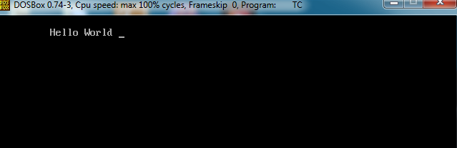

1. **Write a C Program to take Two Numbers and Performs Addition , Subtraction ,multiplication and Division.**

#include<stdio.h>

#include<conio.h>

void main()

{

int a,b,c,d,e,f;

clrscr();

printf("\n\t enter the value of a:");

scanf("%d",&a);

printf("\n\t enter the value of b:");

scanf("%d",&b);

c=a+b;

d=a-b;

e=a*b;

f=a/b;

printf("\n\t Addition is : %d",c);

printf("\n\t Subtraction is : %d",d);

printf("\n\t Multiplication is : %d",e);

printf("\n\t Division is : %d",f);

getch();

}

* **Output :**

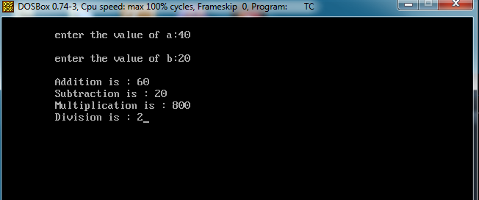

1. **Write a C Program to Find Simple Interest.**

#include<stdio.h>

#include<conio.h>

void main()

{

int SI,p,r,n;

clrscr();

printf("\n\t enter the principle amount:");

scanf("%d",&p);

printf("\n\t enter the rate of interest:");

scanf("%d",&r);

printf("\n\t enter the number of years:");

scanf("%d",&n);

SI=p*r*n/100;

printf("\n\t Simple Interest is : %d",SI);

getch();

}

* **Output :**

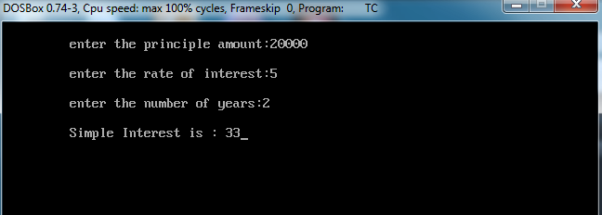

1. **Write a C Program to Find Compound Interest.**

#include<stdio.h>

#include<conio.h>

#include<math.h>

void main()

{

float p,r,t,CI;

clrscr();

printf("\n\t enter the value of principle amount:");

scanf("%f",&p);

printf("\n\t enter the value of rate:");

scanf("%f",&r);

printf("\n\t enter the value of time:");

scanf("%f",&t);

CI=p*pow((1+r/100),t)-p;

printf("\n\t Compound Interest is :%f",CI);

getch();

}

* **Output :**

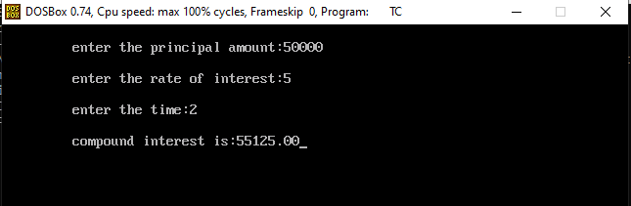

1. **Write a C Program to Find Area of Circle.**

#include<stdio.h>

#include<conio.h>

#define PI 3.14

void main()

{

int r;

float area;

clrscr();

printf("\n\t enter the radius:");

scanf("%d",&r);

area=PI*r*r;

printf("\n\t Area of Circle is :%.2f",area);

getch();

}

* **Output :**

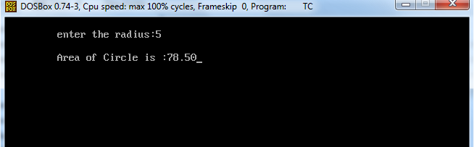

1. **Write a C Program to Find Area of Triangle.**

#include<stdio.h>

#include<conio.h>

void main()

{

int b,h;

float area;

clrscr();

printf("\n\t enter the base value:");

scanf("%d",&b);

printf("\n\t enter the height value:");

scanf("%d",&h);

area=(b*h)/2;

printf("\n\t Area of Triangle:%.2f",area);

getch();

}

* **Output :**

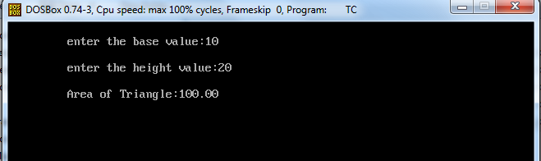

1. **Write a C Program to Find Area of Rectangle 0.5*l*b.**

#include<stdio.h>

#include<conio.h>

void main()

{

int b,l,area;

clrscr();

printf("\n\t enter the value of breadth:");

scanf("%d",&b);

printf("\n\t enter the value of length:");

scanf("%d",&l);

area=0.5*l*b;

printf("\n\t Area of Rectangle :%d",area);

getch();

}

* **Output :**

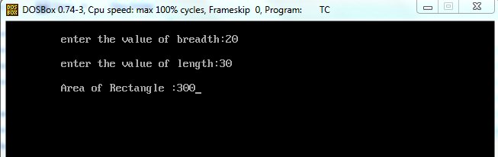

1. **Write a C Program to prepare Marksheet Count , Total , Grade , Percentage.**

#include<stdio.h>

#include<conio.h>

void main()

{

int rollno;

char name[30];

float sub1,sub2,sub3,per,total,grade;

clrscr();

printf("\n\t enter the student roll no:");

scanf("%d",&rollno);

printf("\n\t enter the student name:");

scanf("%s",&name);

printf("\n\t enter the marks of sub1:");

scanf("%f",&sub1);

printf("\n\t enter the marks of sub2:");

scanf("%f",&sub2);

printf("\n\t enter the marks of sub3:");

scanf("%f",&sub3);

printf("\n\t**************************************");

total=sub1+sub2+sub3;

printf("\n\t Total Marks :%.2f",total);

printf("\n\t**************************************");

per=total/300*100;

printf("\n\t Percentage :%.2f",per);

printf("\n\t**************************************");

if(per>=90)

{

printf("\n\t Grade is : A");

}

else if(per>=80)

{

printf(\\"\n\t Grade is : B");

}

else if(per>=70)

{

printf("\n\t Grade is : C");

}

else if(per>=60)

{

printf("\n\t Grade is : D");

}

else if(per>=40)

{

printf("\n\t Grade is : E");

}

else

{

printf("\n\t Fail");

}

printf("\n\t************************************");

getch();

}

* **Output :**

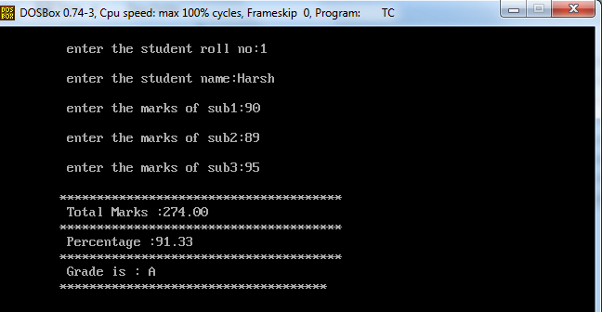

1. **Write a C Program to Check Number is Zero , Positive or Negative.**

#include<stdio.h>

#include<conio.h>

void main()

{

int n;

clrscr();

printf("\n\t enter the value of n:");

scanf("%d",&n);

if(n>0)

{

printf("\n\t Number is Positive");

}

else if(n<0)

{

printf("\n\t Number is Negative");

}

else

{

printf("\n\t Number is Zero");

}

getch();

}

* **Output :**

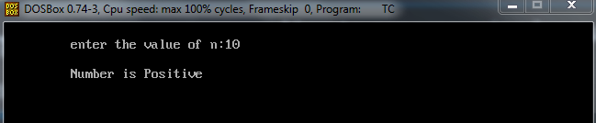

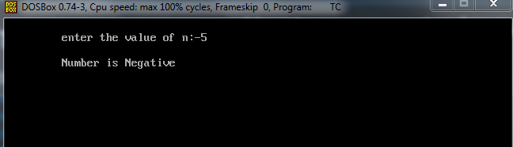

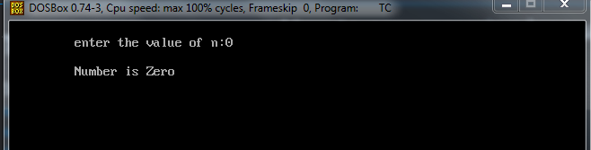

1. **Write a C Program to Swap two Number.**

#include<stdio.h>

#include<conio.h>

void main()

{

int a,b;

clrscr();

printf("\n\t enter the value of A:");

scanf("%d",&a);

printf("\n\t enter the value of B:");

scanf("%d",&b);

a=a+b;

b=a-b;

a=a-b;

printf("\n\t****************************************");

printf("\n\t value of A:%d",a);

printf("\n\t value of B:%d",b);

getch();

}

* **Output :**

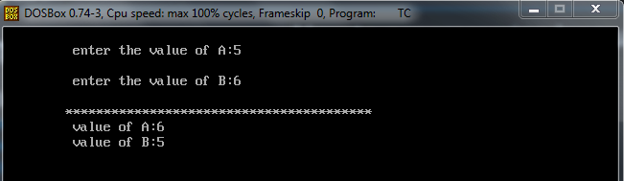

1. **Write a C Program to check Number is Even or Odd.**

#include<stdio.h>

#include<conio.h>

void main()

{

int n;

clrscr();

printf("\n\t Enter the value of n:");

scanf("%d",&n);

if(n%2==0)

{

printf("\n\t Even Number");

}

else

{

printf("\n\t Odd Number");

}

getch();

}

* **Output :**

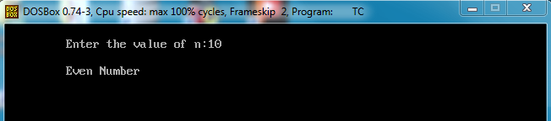

1. **Write a C Program to Find Greatest number between Two.**

#include<stdio.h>

#include<conio.h>

void main()

{

int a,b;

clrscr();

printf("\n\t Enter the value of a:");

scanf("%d",&a);

printf("\n\t Enter the value of b:");

scanf("%d",&b);

if(a>b)

{

printf("\n\t A is greater than B");

}

else

{

printf("\n\t B is greater than A");

}

getch();

}

* **Output :**

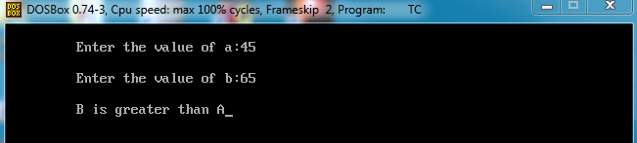

1. **Write a C Program to print 1 to 10 Numbers.**

#include<stdio.h>

#include<conio.h>

void main()

{

int i,n;

clrscr();

printf("\n\t Enter the value of n:");

scanf("%d",&n);

for(i=0;i<=n;i++)

{

printf("\n\t %d",i);

}

getch();

}

* **Output :**

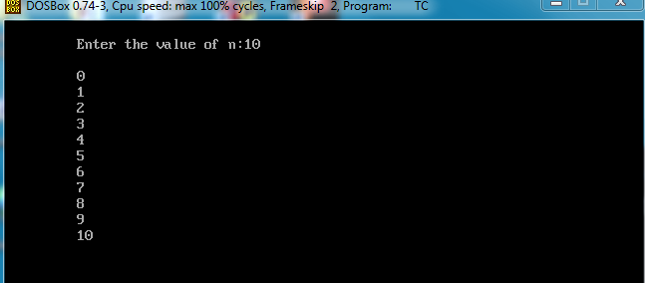

1. **Write a C Program to Check Wether Number is Prime or Not.**

#include<stdio.h>

#include<conio.h>

void main()

{

int i,n;

clrscr();

printf("\n\t Enter the value of n:");

scanf("%d",&n);

for(i=2;i<=n;i++)

{

if(n%i==0)

{

break;

}

}

if(i==n)

{

printf("\n\t Prime Number");

}

else

{

printf("\n\t Not Prime Number");

}

getch();

}

* **Output :**

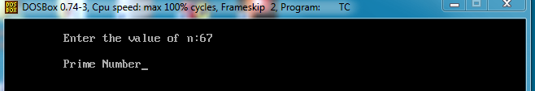

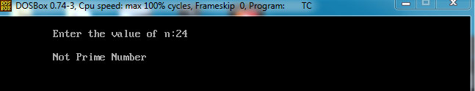

1. **Write a C Program to print Fibonacci Series.**

#include<stdio.h>

#include<conio.h>

void main()

{

int i,n,a=0,b=1,c;

clrscr();

printf("\n\t Enter the value of n:");

scanf("%d",&n);

for(i=1;i<=n;i++)

{

printf("\n\t%d",a);

c=a+b;

a=b;

b=c;

}

getch();

}

* **Output :**

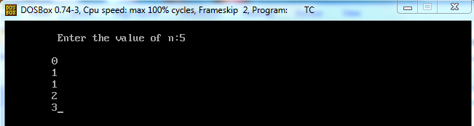

1. **Write a C Program to print Reverse Number.**

#include<stdio.h>

#include<conio.h>

void main()

{

int rem,rev=0,n;

clrscr();

printf("\n\t Enter the value of n:");

scanf("%d",&n);

while(n!=0)

{

rem=n%10;

rev=rev*10+rem;

n=n/10;

}

printf("\n\t Reverse Number :%d",rev);

getch();

}

* **Output :**

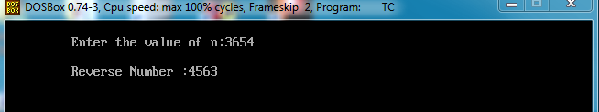

1. **Write a C Program to Check Whether number is Palindrome or Not.**

#include<stdio.h>

#include<conio.h>

void main()

{

int n,r,sum=0,temp;

clrscr();

printf("\n\t Enter the value of n:");

scanf("%d",&n);

temp=n;

while(n>0)

{

r=n%10;

sum=sum*10+r;

n=n/10;

}

if(temp==sum)

{

printf("\n\t Palindrome Number");

}

else

{

printf("\n\t Not a Palindrome Number");

}

getch();

}

* **Output :**

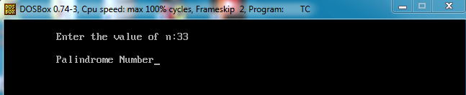

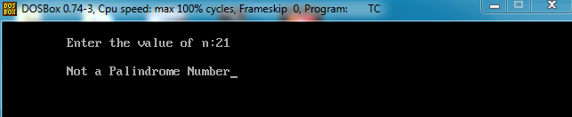

1. **Write a C Program to Check Armstrong Number or Not.**

#include<stdio.h>

#include<conio.h>

void main()

{

int n,r,sum=0,i;

clrscr();

printf("\n\t Enter the value of n:");

scanf("%d",&n);

i=n;

while(n>0)

{

r=n%10;

sum=sum+(r*r*r);

n=n/10;

}

if(i==sum)

{

printf("\n\t ARMSTRONG NUMBER");

}

else

{

printf("\n\t NOT ARMSTRONG NUMBER");

}

getch();

}

* **Output :**

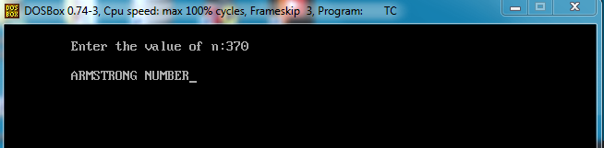

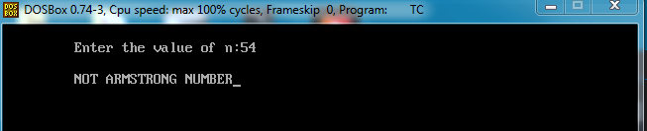

1. **Write a C Program to Print Array and Sum of Array.**

#include<stdio.h>

#include<conio.h>

void main()

{

int a[3][3],i,j,sum=0;

clrscr();

for(i=0;i<=2;i++)

{

for(j=0;j<=2;j++)

{

printf("\n\t Enter the Element a[%d][%d]:",i,j);

scanf("%d",&a[i][j]);

}

}

printf("\n\t--------------------MATRIX--------------------------\n");

for(i=0;i<=2;i++)

{

for(j=0;j<=2;j++)

{

printf("\t%d",a[i][j]);

}

printf("\n");

}

printf("\t----------------------------------------------------\n");

for(i=0;i<=2;i++)

{

for(j=0;j<=2;j++)

{

sum=sum+a[i][j];

}

}

printf("\t SUM is : %d",sum);

printf("\n\t*********************************************************");

getch();

}

**Output :**

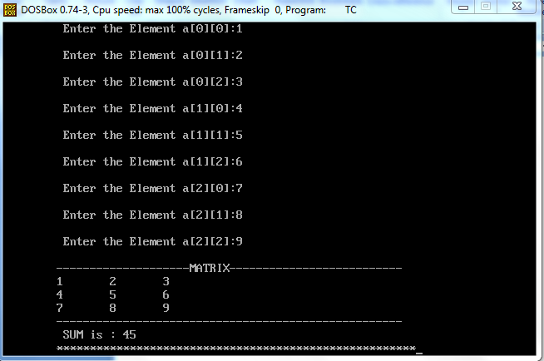’

1. **Write a C Program to print 2-D Array.**

#include<stdio.h>

#include<conio.h>

void main()

{

int a[3][3],i,j;

clrscr();

for(i=0;i<=2;i++)

{

for(j=0;j<=2;j++)

{

printf("\n\t Enter the element a[%d][%d]:",i,j);

scanf("%d",&a[i][j]);

}

}

printf("\n\t *********************** TWO DIMENSION ARRAY ***********************\n");

for(i=0;i<=2;i++)

{

for(j=0;j<=2;j++)

{

printf("\t %d",a[i][j]);

}

printf("\n");

}

getch();

}

* **Output :**

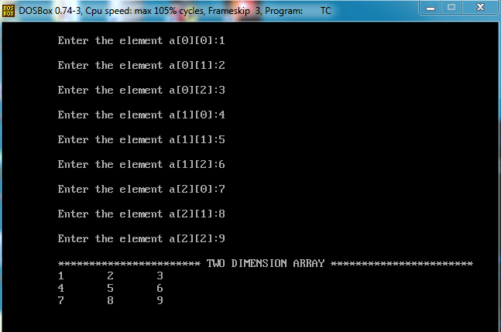

1. **Write a C Program to Find a Linear Search Element .**

#include<stdio.h>

#include<conio.h>

void main()

{

int a[50],n,i,key;

clrscr();

printf("\n\t Enter the size of an Array:");

scanf("%d",&n);

printf("\n\t ****************************************\n");

for(i=0;i<n;i++)

{

printf("\n\t Enter the elements of a[%d]:",i);

scanf("%d",&a[i]);

}

printf("\n\t------------------------------------------------\n");

for(i=0;i<n;i++)

{

printf("\t%d",a[i]);

}

printf("\n\t------------------------------------------------\n");

printf("\n\t Enter the key element to be search:");

scanf("%d",&key);

for(i=0;i<n;i++)

{

if(a[i]==key)

{

break;

}

}

printf("\n\t ************** Linear Search ******************\n");

if(key==a[i])

{

printf("\n\t Successful Search at a[%d]:",i);

}

else

{

printf("\n\t Unsuccessful Search");

}

getch();

}

* **Output :**

